“A TOUCH OF FRANCE 2016”

PARTICIPATION OPTIONS

From 23 to 25 novembre 2016 at the Spanish Court Hotel (Kingston)
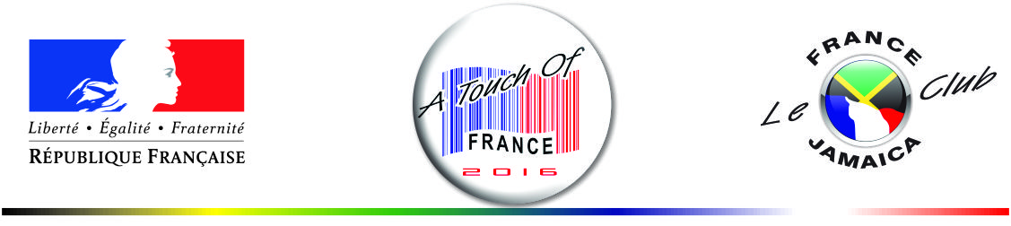

PARTNERS

The financial contribution of the partner companies is directly negotiated between them and organisers.

SPONSORS
- JA$250,000
- « Sponsors » will be acknowledged and logos will be displayed on all official promotional items (banners, press kits, programme, adverts etc.).
- Sponsor banners will be displayed in Touch of France and by the stage area
- Participation to the Press conference.
- A Double booth space (16’x8’) is included (see Option II below).
- Possible additional exposure can be negotiated.

JUNIOR SPONSORS
- JA $150,000
- « Junior Sponsors » name and logo will be displayed in press kit and programme.
- Product banners given by the junior sponsors will be displayed in Touch Of France.
- Logo will be displayed along other junior sponsors’ logos on the event banner.
- A Single booth space (8’x8’) is included.

EXHIBITORS BOOTH OPTIONS

OPTION I | - JA$60,000 Single Booth space  - 8’X8’ Booth space, including one table with skirting, 2 chairs and electrical outlet
OPTION II | - JA $120,000 Double Booth space  - 16’X 8’ Booth space, including 2 tables with skirting, 4 chairs and electrical outlet
ON THE BOOTH SELLING OPTION | An additional JA$60,000 is requested from exhibitors selling products on their booth.

CULTURAL ORGANISATIONS

Cultural organisation will get a space with a table and 2 chairs. A participation of JA$ 2000 is requested.

